Starting the Paradigm Shift in Your Church
The Great Commission process is clear and must be applied to your church by:
- Making disciples of your current congregation!
- Teaching them to observe all Jesus commanded
Make disciples of your current congregation
This is a conversion process where the emphasis of preaching and teaching is placed on the person and nature of Jesus. It is the suggestion of Teaching4Jesus Ministries that you start by:
- Redefining the Gospel that focuses on Jesus not forgiveness and heaven
  - Acts 2:14-36
  - Romans 1:1-17
  - 1 Corinthians 15
Next, concentrate a year of preaching and teaching according to your church’s needs to create the shift to a greater service by everyone in your congregation.
Teaching4Jesus Ministries is your partner in the Paradigm Shift. Here’s how we can help:
- Relevancy Forum: Defending the three core values of the Christian faith: The Bible, Jesus, and the Church
Discipleship Demands a Cross
A biblical study to make cross-bearing disciples!
- Serve Like Jesus Training: Creating cross-carrying disciples who Serve Like Jesus
- Focus on Jesus Seminar: Deep dive teaching into the person and nature of Jesus
We do this live at your church, virtually, or training your leadership to lead these paradigm shifting opportunities.
Understanding Discipleship DNA
Jesus commissioned us to make disciples who share His DNA
Discipleship DNA is in the Spirit driven follower of King Jesus who is devoted to kingdom service.
This concept is understood from two essential elements of the Commission:
- Baptize the Disciple
  - Into Christ
  - Put on Christ
  - Participate in His Passion
- Teach the Disciple
  - To Observe (Acts 2:42)
  - All Commands
The clear and undisputed core of the commission is Jesus’ declaration of authority. He has the right to insist that people who believe He is Lord should commit to service in His kingdom.
Question: If becoming a disciple precedes baptism, why are all of the discipling programs for believers in the church?
Is it time for a paradigm shift in our Theology of Discipleship?
Covenant
While the picture of slavery is often a revival theme to talk of freedom in Christ, we have seen that the Biblical picture is far more expressive than merely bought to be free. In fact, there is great freedom in our new covenant that God has made with us through the blood of His Son. As Solomon verifies, “O Lord, the God of Israel, there is no god like You in heaven or on earth, keeping covenant and showing lovingkindness to Your servants who walk before You with all their heart” (2 Chronicles 6:14).
Model #2
As citizens of the Beloved Son, we have confidence to “draw near with a sincere heart in full assurance of faith” (Hebrews 10:22). This is because we are baptized disciples, focused and ready to learn the full will of our King.
This confidence in our covenant relationship is bonded by the blood of our Messiah, King Jesus. Paul connects this to service to our king by stating that “our adequacy is from God who also made us adequate as servants of a new covenant” (2 Corinthians 3:5-6). The term for adequacy used by Paul holds the idea of having all we need for service, which is available when we allow the Spirit of God to teach us all that Jesus commanded.
Question: If you are convinced that there is a need in your church to make this paradigm shift in your theology of discipleship, what’s the next step?
Ransom
Model #1
Most teaching on the Ransom Model limit the thought to the price paid (the blood of Christ). However, to fully understand the impact of this model on being a devoted disciple, it is imperative to understand the concept of slavery in NT times that gives the example.
There were three primary reasons someone might be a slave:
- They were captured during war
- They were born into slavery
- They had a debt that could not be paid
This is perfectly descriptive of the human condition
- We were born to die and thus, under the bondage of the devil, held by the fear of death
- We are held captive by the one who holds the fear of death (Hebrews 2:14b-15)
- We are under the debt of sin (Colossians 2:14)
To free someone from slavery a person with means goes to the slave market to buy a slave to work for them. This is not a picture of freedom! Rather, it portrays a price paid that led to a change of ownership!
Ransomed to Serve
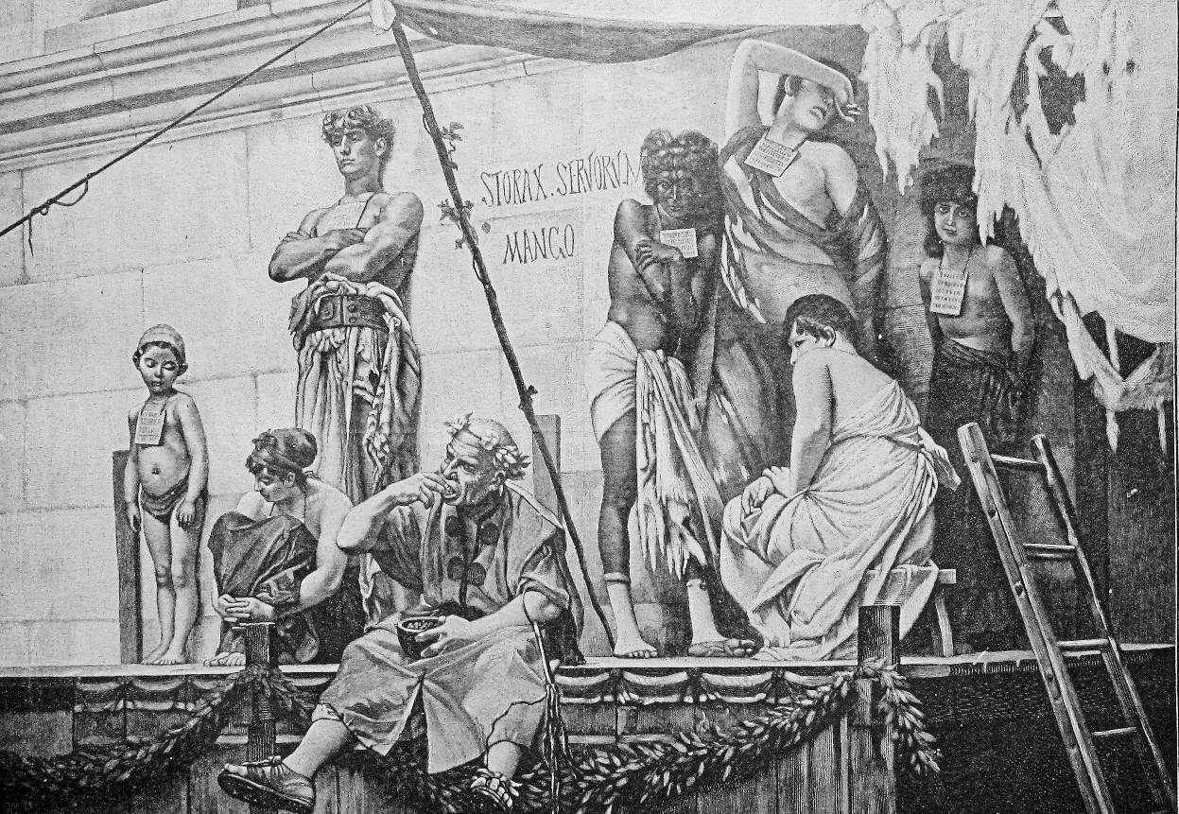
Under the rule of King Jesus, we are to dedicate our whole being to Him – heart, mind, soul, and body. This is why Paul tells us that “you are not your own? For you have been bought with a price. Therefore, glorify God in your body.” Thus, the slave glorifies his king.
The Need for a Paradigm Shift in the Theology of Discipleship
Whether your church is growing, plateaued, or declining, the reality is that not all in attendance or on the church registers could be described as a dedicated servants to King Jesus.
The 80/20 rule is still the guiding principles of service in most churches. Wayne Schmidt tells us that “Many churches have found that—
- 80 percent of the income is given by 20 percent of the people.
- 80 percent of the serving is done by 20 percent of the people.
- 80 percent of the prayer is offered by 20 percent of the people.
- 80 percent of the witnessing is accomplished by 20 percent of the people.”*
Yet, 100% say they are disciples of King Jesus!
Question: What caused this?
After considerable study and prayer, it is the belief of Teaching4Jesus Ministries that the problem goes back to this:
To WHAT were they converted?
The thought is that many were converted merely to the idea of being forgiven and going to heaven. In other words, they feel safe, and nothing was ever said about a life of service to King Jesus.
*Wayne Schmidt, Ministry Velocity: The Power for Leadership Momentum (Indianapolis, IN: WPH, 2010), 187–188.
Hum! This makes sense. Tell me more.
Comparing Two Approaches
Contemporary Practices | New Testament Practice
Focuses on the believer:  - Emphases salvation, not allegiance to King Jesus  - Highlights going to heaven  - Promotes happiness, safety, and being blessed | Jesus said,  - Deny yourself, and take up his cross and follow Me.  - The first shall be last, servant of all.  - Whoever wishes to be first shall be slave of all.
Basis of the NT Practice
The heart of service comes from Jesus’ announcement of His imminent death and resurrection. Thus, discipleship is modeled by Jesus:
“For even the Son of Man did not come to be served, but to serve, and to give His life a ransom for many.”
This becomes the model for the disciple making paradigm shift needed to reverse the current pattern.
Discipleship is Replicating the Model of Jesus Service!
Principle #3
Mark’s Gospel records Jesus’ statement of going to Jerusalem three different times (8:31; 9:31; 10:33). The intent of this was to show the model of Jesus’ service – His imminent death, burial, and resurrection.
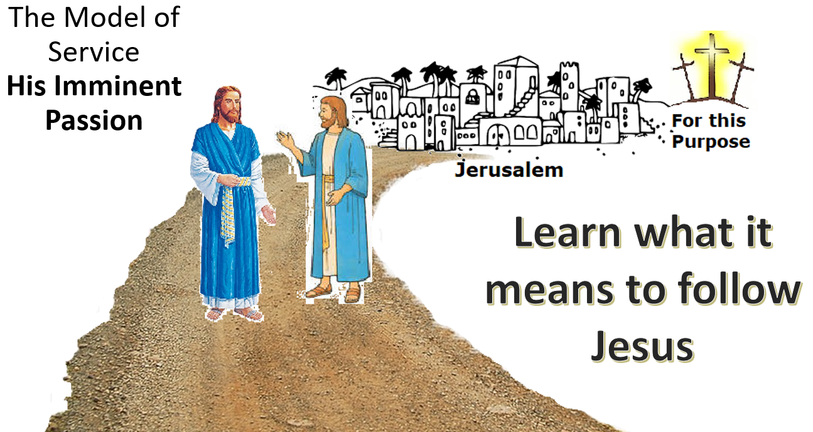
Jesus’ devotion to doing God’s will (Hebrews 10:7) is the model of Jesus’s service (Mark 10:45). As citizens in His kingdom (the church), we should be driven by the same passion, discovering our spiritual gifts paired with our natural abilities (Matthew 25:14-30). Beyond giftedness, He appointed all of His disciples to be His Ambassadors. Ours is a ministry of reconciliation (2 Corinthians 5:20).
Based on this, if everyone is making disciples, every church should multiply rather than having additions.
These principles are supported by two biblical models that teach the disciples the needed attitude to be a fruitful citizen in the Beloved Son’s kingdom.
Discipleship Must Happen during Conversion
Principle #2
For this principle, look at Jesus’ disciples when they are called:
In all four Gospels, the language indicates the moment a conscious decision was made (Matthew 4:22; Mark 1:18; Luke 5:11; John 1:37). In each case, there was an emphasis on leaving and following and leaving was not without cost:
- Mark, in his typical, simple manner, states they left nets (1:18).
- Matthew adds value by stating the loss of the family business (4:22)
- Finally, Luke declares that they left everything (5:11)!
Matthew and Mark include the statement “come after me.” This puts them in the position of following the leader. While Luke does not use this expression, he does use the same result of following that Jesus states to make them fishers of me (Ambassadors for Christ).
Thus, according to Jesus in the Gospel model, to be a disciple means:
- Decide to follow Jesus
- Find others and offer them the opportunity to follow Jesus (fishers of men/Ambassador)
As with Jesus’ disciples and those in Acts, this is done at the time of what we commonly call conversion. For too long, the impact of the Reformation and Revivalism has made us focus on being saved rather than becoming a devoted follower of Jesus. They are not the same.
Disciple Making Paradigm Shift
Paul paints the clearest picture of the paradigm shift in Colossians 1:13-14.
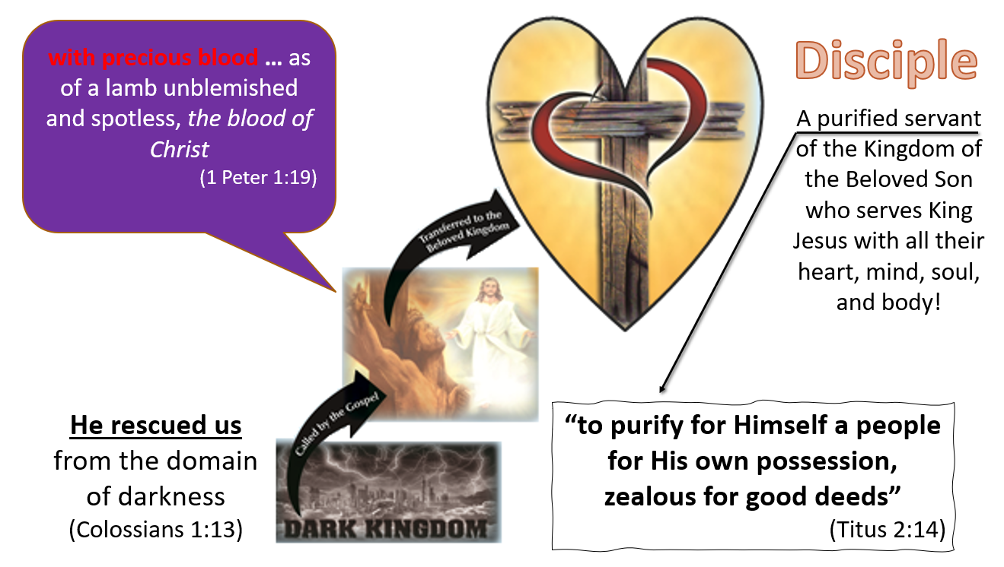
Let’s break this down:
Rescued: The fact that humanity is corrupt and needed rescued is irrefutable. We live under the fear of death and the hold that it has on us (Hebrews 2:15).
The appeal to leave that life of slavery is by the Gospel (2 Thessalonians 2:14). What would prompt us to leave this world to which we are natural citizens? Only the one who conquered death by His resurrection.
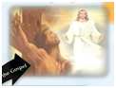
Transferred: He rescued us from the domain (authority) of darkness, and transferred us to the kingdom of His beloved Son, in whom we have redemption, the forgiveness of sins.
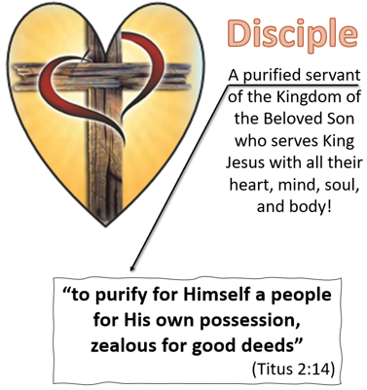
The Kingdom: The transfer was into a kingdom where the citizens would be expected to live in harmony under the rule of the conqueroring King.
Principle #1
Paul concludes this section with two vital points about being qualified to be a citizen in the Kingdom of the Beloved Son – possession and forgiveness.
Forgiveness: The sins of the new citizens are removed so that they are now clean enough (purified) to serve the King – “purify for Himself a people.” Before dealing with possession (redemption), it is vital to note the basis for the rescue, transfer, and kingdom citizenship.
After revealing what God had done for the Colossians (can and will do for anyone obedient to the Gospel), Paul lays the only foundation on which such a change can take place – the preeminence of Jesus.
(Colossians 1:15-18).
Here is Paul’s description of the Beloved King:
- He is the image of the invisible God
- The firstborn of all creation.
- By Him, all things were created
- He is before all things, and in Him all things hold together
- He is also head of the body, the church
- He is the beginning, the firstborn from the dead
Having laid the only foundation on which discipleship is based, let’s examine 3 Biblical Principles for making New Testament Disciples.
The Gospel that Makes Disciples Focuses on Jesus not Salvation!
Contemporary evangelism focuses on people being saved, sins forgiven, and going to heaven. To see New Testament evangelism in practice, examine the very first Gospel message to non-Christians – Acts 2.
Peter’s Proposition: “Everyone who calls on the name of the Lord will be saved (rescued)” (NASB95, Acts 2:21) “from this perverse generation” (Dark Kingdom) (Acts 2:40).
- Focus: Jesus of Nazareth (Acts 2:22)
  - “Attested to you by God with miracles and wonders and signs”
  - “Delivered over by the predetermined plan and foreknowledge of God (Acts 2:23)
  - “God raised Him up again, putting an end to the agony of death” (Acts 2:24)
- Supported by OT Prophecy
  - Spirit poured out in the last days (Acts 2:17).
  - David and the Resurrection (Acts 2:25-30).
- Conclusion: God has made Him both Lord and Christ
- Response: Pierced to the heart
  - This is the response that makes disciples
Peter’s Gospel was about Jesus – who He was and what He did. He did not preach a sin and hell focus on the believer. He preached about Jesus.
Paul’s Gospel in Romans 1:1-4 and 1 Corinthians 15 have the same focus. Both passages, just like Peter’s sermon, emphasizes the resurrection as this is the essential element that led to His Lordship. See this in light of Romans 8:24 and the coronation of King Jesus.

