Now…What About church?
It is obvious that God has limited His control because the world is still a mess. So, where is God in control? He is controlling the church under the Lordship of King Jesus. The church is designed to be an outpost for the heavenly kingdom under the control of Jesus, advancing God’s plan in our world.
The Kingdom of the Beloved Son
You may hear or say this, “I do not like organized Christianity.” What is meant is they don’t like the churches they see today. However, when you know what church really should mean, it makes more sense.
The Real Church
Church means that you are now in a proper, friendly relationship with God in King Jesus. It is a place to be with other believers who, like you, want to learn more about what King Jesus taught us. Thus, the local church is the physical body of disciples for that location, doing the ministry of making new friends of God through the gospel of King Jesus.
Learn more about Jesus and His church at …
Teaching4Jesus Ministries
Zephyrhills, Florida 33542
www.Teaching4Jesus.org
(813) 310-1110
What Has Happened to Our World?

Evidence proves
He has not!
What a Mess!
It would seem to many that the world is in a mess. Natural calamities, senseless violence, brutality, and crime go hand in hand with an alarming increase in purposeless relativism, moral decline, and gross materialism that raises the question of whether God has abandoned humanity. Where is God in all this?
The Good News!
We have not been abandoned.
God has taken charge in an unexpected way in and through Jesus. What does this mean? Let’s take a look at God’s unique plan to regain control. It is a simple, perfect plan. Here it is in a nutshell:
The Gospel (Good News) about Jesus
Jesus appears in human history years ago, yet He existed before His entrance into our world. His birth had been predicted, anticipated, and realized after years of preparation. God in and as Jesus came here to restore His rightful place as ruler over this world. To accomplish this, Jesus had to die, but thanks be to God, He conquered death, giving humans hope by taking away the fear that death uses to control us. By His resurrection, God has made Jesus Lord (King) over those who believe in Him and are willing to let King Jesus rule over their lives as citizens in His kingdom.
Isn’t this great news? Now, we have some vital questions to answer that many ask.
A New Life!
If you have obeyed from the heart the form of the teaching, you belong to King Jesus. “You are not your own? For you have been bought with a price. Therefore, glorify God in your body.”
Transferred
Once you are transferred into the kingdom of the Beloved Son, your citizenship changes. You …
- … learn to live under kingdom rules
  - One purpose of the church is to teach you the rules
- … share the Good News with others of who Jesus is and what He has done so they can benefit from citizenship in the beloved kingdom
- … help increase God’s influence in the world
Now, Serve Like Jesus
“For even the Son of Man did not come to be served, but to serve, and to give His life a ransom for many.”
Having Jesus’ Spiritual DNA, we will serve. How?
- By finding a local body of believers and learning what Jesus has taught us
- By serving Lord Jesus in a local body of believers, using your natural abilities and the gifts the Spirit will give you
- Living as a new creation, promoting Him through His body on earth – the church
- Proudly serve as His Ambassador, spreading the Good News about Jesus
Here’s How This Works
The form of the Gospel is Jesus’ death, burial, and resurrection, which were historical realities. To obey the form, the Bible tells us that we must be baptized, which is our moment in history when we are bought with the precious blood of Jesus and transferred into His kingdom. Picture it this way:
Here are the benefits of obedience:
  - His death – forgiveness of past, present, and future sins and their consequences
  - Burial – die to our sins so we can be raised in His likeness to live under His kingdom rule
  - Resurrection – made to be like Him by His Spirit that raised Jesus
    - Jesus gives us the gift of His Spirit to live in us and keep the picture of Jesus fresh in our hearts and mind
    - The Spirit does this by sharing Jesus’ nature with us, helping us value Jesus more
How Do We Know This?
This is a good question that deserves an answer. We believe that the Bible as we have it today is the only reliable source for the truth about God’s work in Jesus. Here’s why:
- The multiple copies of the text (more than 5000) come from three separate places in and around the Mediterranean Sea
  - Yet, the texts vary in only minor details and none of these have an impact on the major teachings about Jesus and what He taught
- These documents are within 3 centuries of Jesus’ life (by comparison, there are only 10 documents of Julius Caesar’s writings and the oldest one was written 1,000 years after he lived)
- The church used these books soon after they were written, protecting them
- This means that God protected the Bible and put His message in it for us
Where Do We Start?
The foundation of the Christian faith is what you think of Jesus, which means you must believe:
- He was a real person God had predicted would come and set things in order
- He came to do God’s will
- He is God and this was proven by the miracles He performed and His resurrection
- God lifted Him to a place of absolute authority over the world
- Jesus will come back to earth to judge the world
More about Jesus
- He is the way, the truth, and the life. No one comes to the Father but through Jesus
- God highly exalted Him, and gave Him the name which is above every name
Also, Jesus …
- … knew He fulfilled what was predicted by the prophets of Israel
- … was recognized by the people as the son of Israel’s King, David
- … spoke with authority, telling people what God wanted them to know
- … died on a cross, which is an unquestioned, historical fact
- … was buried as proof of His death
- … was declared the Son of God with power by the resurrection from the dead
- … was crowned King of God’s kingdom in this world
- … has the right to judge our lives!
Conclusion:
Why is this Good News?
Jesus is Lord over God’s kingdom!
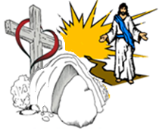
You can be a citizen in God’s kingdom by becoming a disciple devoted to King Jesus! Here’s how this works:
- God Qualifies Us “to share in the inheritance of the saints” by forgiving our sins through the death of His Son Jesus
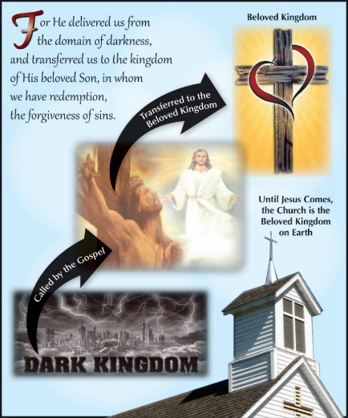
- By this, God Rescues Us from the control of lord of this dark world through the resurrection of Jesus
- Freed from the fear of death, God Transferers Us “into the kingdom of His beloved Son” under the Lordship of King Jesus
Why Did God Do This for Us?
Although we rebelled by the way we acted, God demonstrates His own love toward us, in that while we were yet sinners, He redeemed us through the blood of Jesus, separating us for service to King Jesus.
OK, I’m in! Now What?
To become a citizen under Jesus’ rule, you must:
- Be transferred into Him by obeying the Gospel
- “Thanks be to God that though you were slaves of sin, you became obedient from the heart to that form of the teaching.”

